**WOMEN IN MOVIES**

*-Apoorva Gupta, BVCOE*

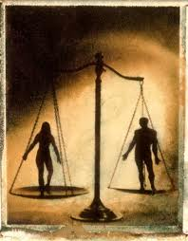

One day I came across an article in the newspaper, according to which a survey conducted by the G20 countries has found that India is the worst place to be a woman, along with the fact that UN has decided to conduct a survey on the portrayal of women in the world cinema. Even, Gurcharan Das mentions in his book, ‘India Unbound’ that the definition of modernization is indeed westernization of the society, including description of the 'modern' women as the cigarette smoking, alcohol consuming, and infidelity doing part of the population.

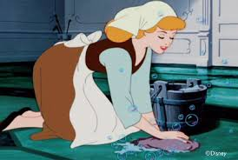Much role played in this regard is by Cinema. It has been showing men, as a villain, a rapist, a drunkard and a smoker, not to mention their portrayal as a royal and super class who always have women (mothers, daughters, sisters or wives) to serve them, to give them a glass of water after every trip they take to the office for they are the bread winner of the family. Although, it shows woman as a successful businesswoman, but seldom have I seen this royal portrayal for the fairer sex. Majority of the times, it is portrayed like the former part of Cinderella, wherein the queen of the business house suddenly becomes a slave at her own house. Here, the point to ponder over is that persons (especially children) gather and emulate what they see. How can we expect our sons to grow up and respect their own sisters when they haven't seen their own fathers respecting their mothers, or sisters? How can we expect them to be gender sensitive when movies (enjoyed by almost everyone) portray that women are there just to serve the interests of men, to be at their beck and call consistently? And the moment she decides to take a stand for herself (like getting out of a bad marriage or maybe speaking against the dowry system or maybe just claiming her rights in the ancestral property or just the fact that an accident rendered her a widow) she is deemed to be an outcaste, sentenced to a life at a place far far away from the place she was brought up in. Somebody questioned me the other day if language used helps to create a gender divide!

Okay, so here's a small test everyone can use- talk to a child of about 5-7 years; ask him questions about the society. It will reflect truly on what the society actually is these days. When they say 'Child is the Father of the Man’, it is actually true. Try this technique and you shall find some closure in the things I have said above. My childhood was in the 90’s. Growing up, I was always taught that there is no difference between the genders. I belong to a family where number of girls is greater than that of boys. Yet, we were all brought up equally with same amount of love and facilities. The rules too have remained unchanged over time. This practice now seems to gradually decrease these days. The other day I met a kid. He studies in a good school in Delhi, has a great number of action figure toys, is nice to talk to, but when you hear him chitter and chatter, it makes us realize where the real fault lies. It’s not in the society within but in the way it is portrayed to these kids when they are young, which they emulate blindly once they grow up and never really spare a moment of thought as to if the practice is liable or not.

The big screens are a big reflection on us and our society. And its time we give a serious thought to what we want to see on them. It’s time to spare a moment of thought.